Exercise 4: Functions

Scenario 1: Calculate the age of customers for eligibility checks.
o Question: Write a function CalculateAge that takes a customer's date of birth as input and returns their age in years.

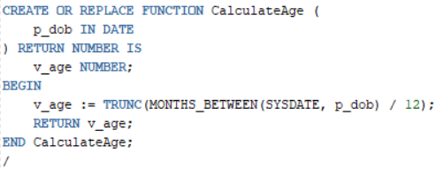
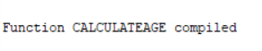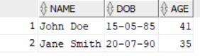

Scenario 2: The bank needs to compute the monthly installment for a loan.
o Question: Write a function CalculateMonthlyInstallment that takes the loan amount, interest rate, and loan duration in years as input and returns the monthly installment amount.
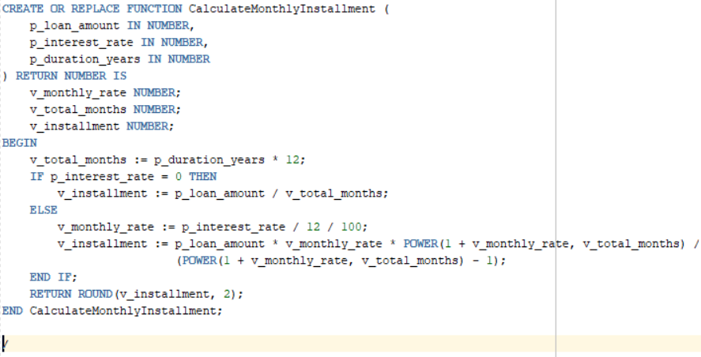
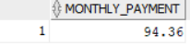

Scenario 3: Check if a customer has sufficient balance before making a transaction.
o Question: Write a function HasSufficientBalance that takes an account ID and an amount as input and returns a boolean indicating whether the account has at least the specified amount.
